**Mahmoud Al Hafez**

**Github:** [**https://github.com/mahmoudKFH/selling_laptops.git**](https://github.com/mahmoudKFH/selling_laptops.git)

**For the ease of testing use the following credentials for admin log in:**

**Email:** [admin@gmail.com](mailto:admin@gmail.com)

**Password**: adminadmin123

**Laptop Portal**

**Login:**

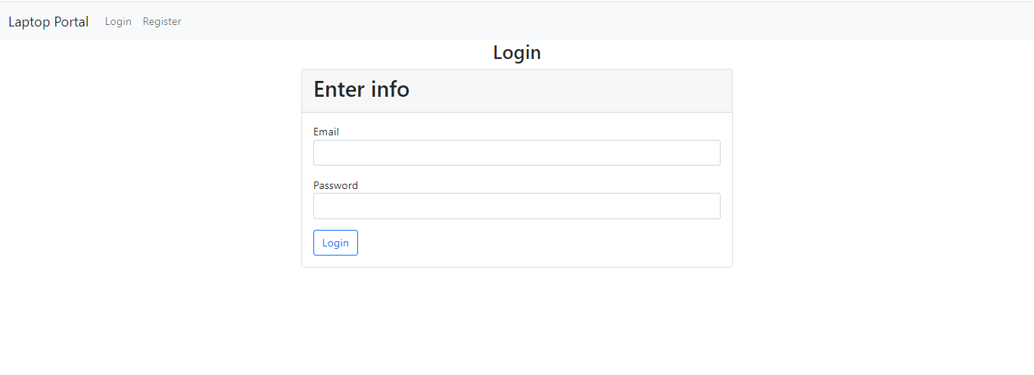

On this screen Customer/Admin can login to the application

**Registration:**

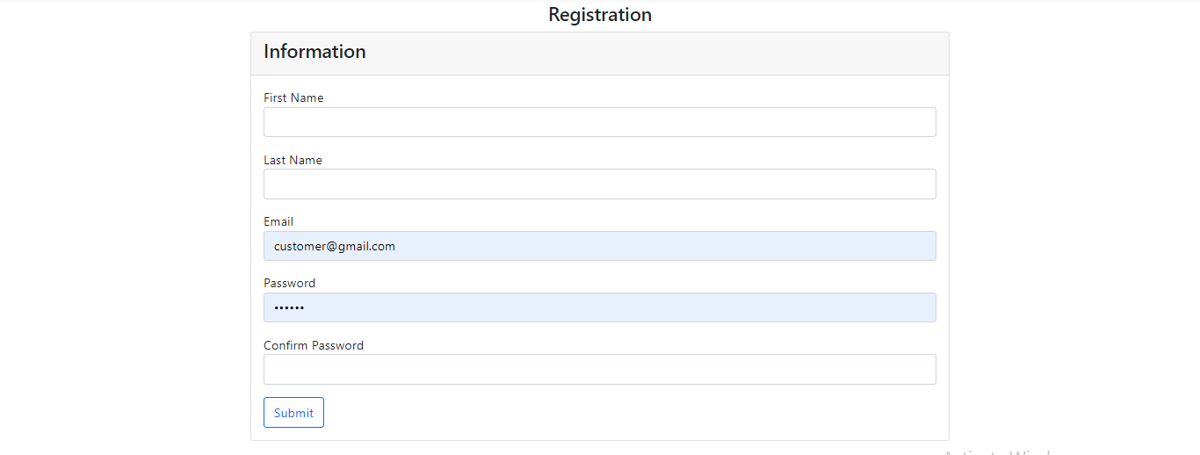

Customer can create new account from this screen.

**Home page:**

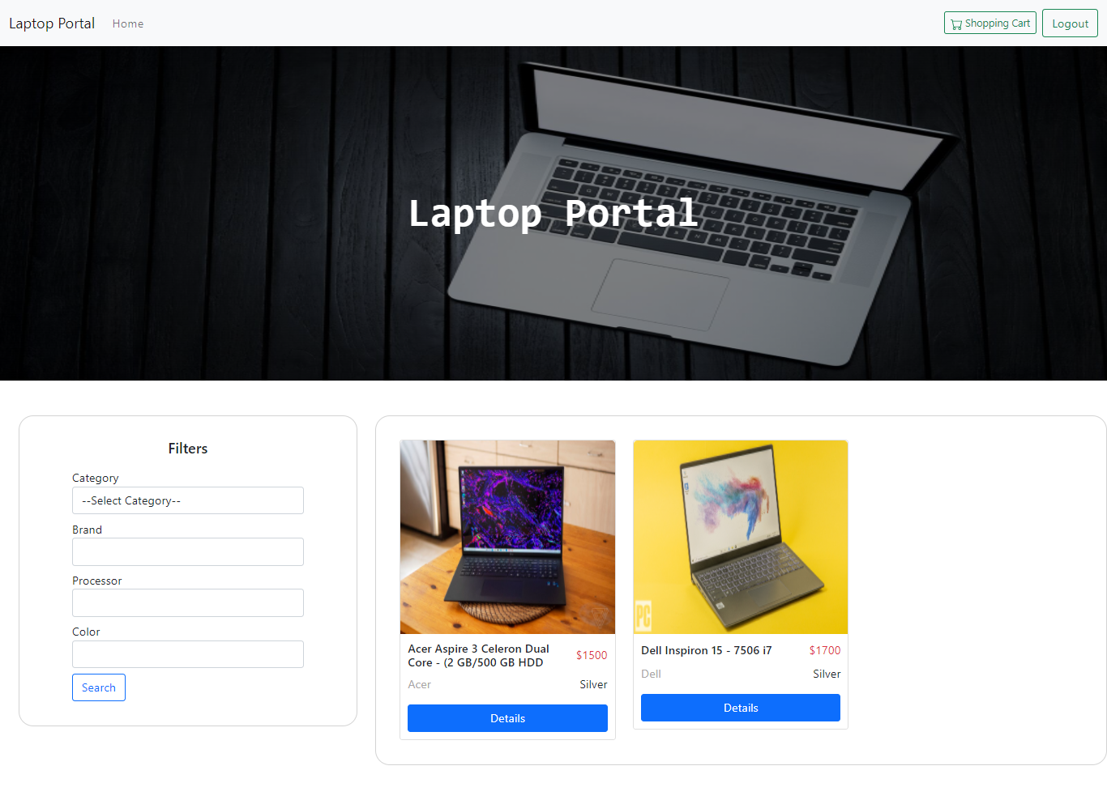

Home page has several options on navbar like, Home, Cart, Logout. It will also contain all listed products of the application

Customer can search different products based on search filters

**Product detail page:**

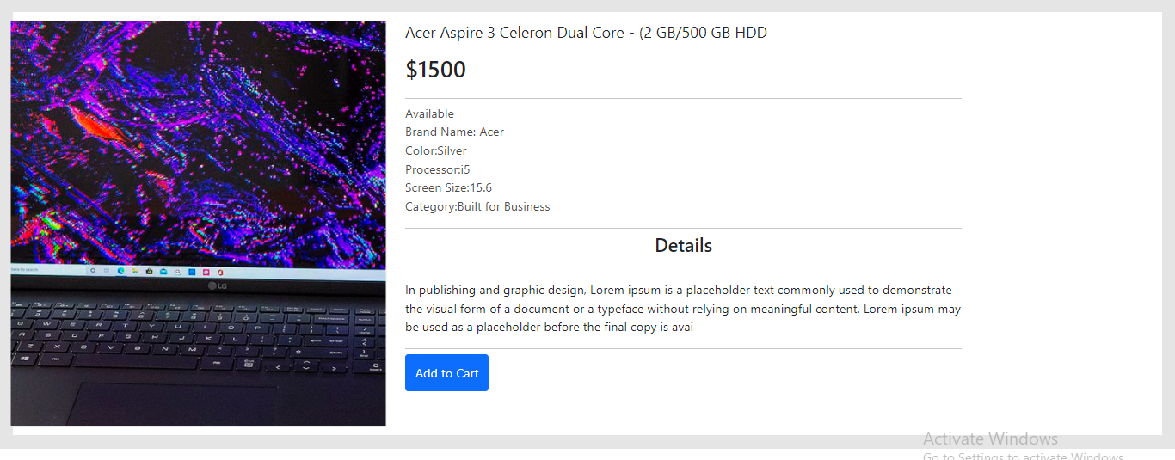

This page contains all information about the product, customer can read the details from here and also can add this product to their shopping cart

**Cart page:**

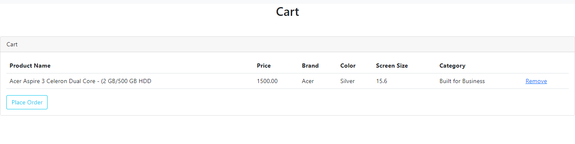

Customers can see their shopping cart details on this page also thy can remove the product from shopping cart as well

Customer can place order on this screen by clicking “Place Order” button

**Order confirmation page:**

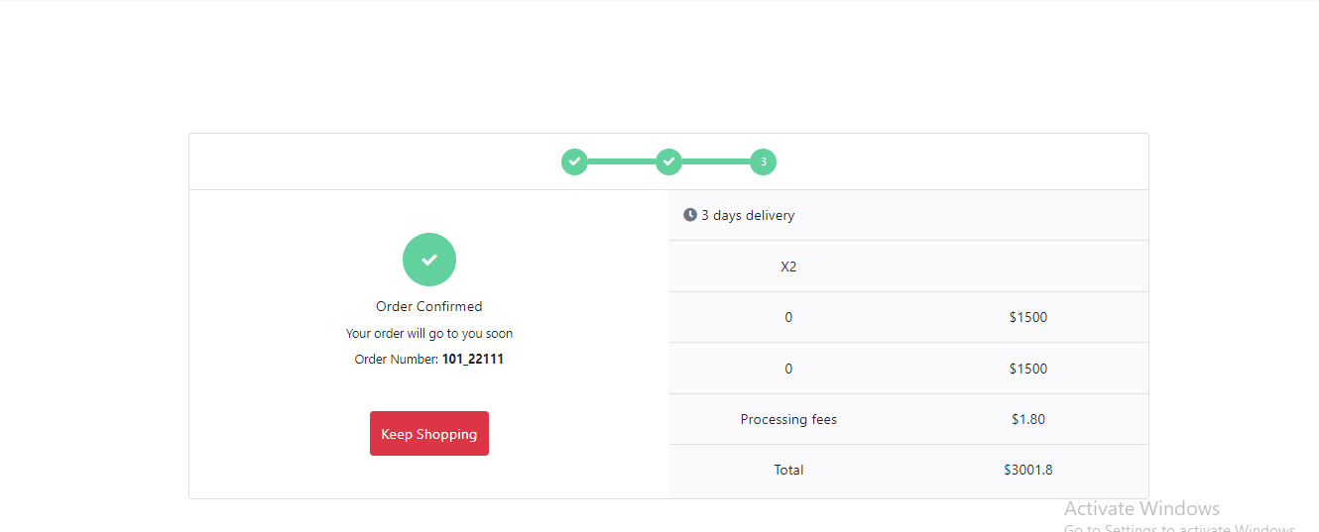

Customers can see their placed order information on this page with total price and delivery days and quantity of products

By clicking on “Keep shopping” customers will be redirected to products page

**Admin Section**

**Home page:**

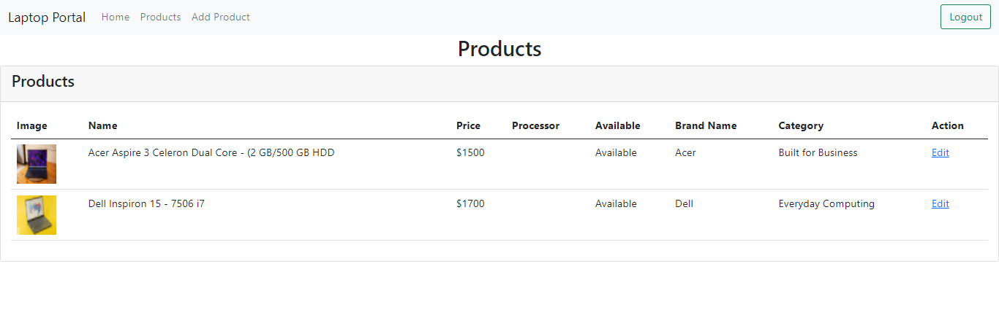

On home page admin can see all listed products of application also they can edit them as well by clicking in “Edit” link.

Home page have several options like Home, Products, Add Product etc.

**Edit product page:**

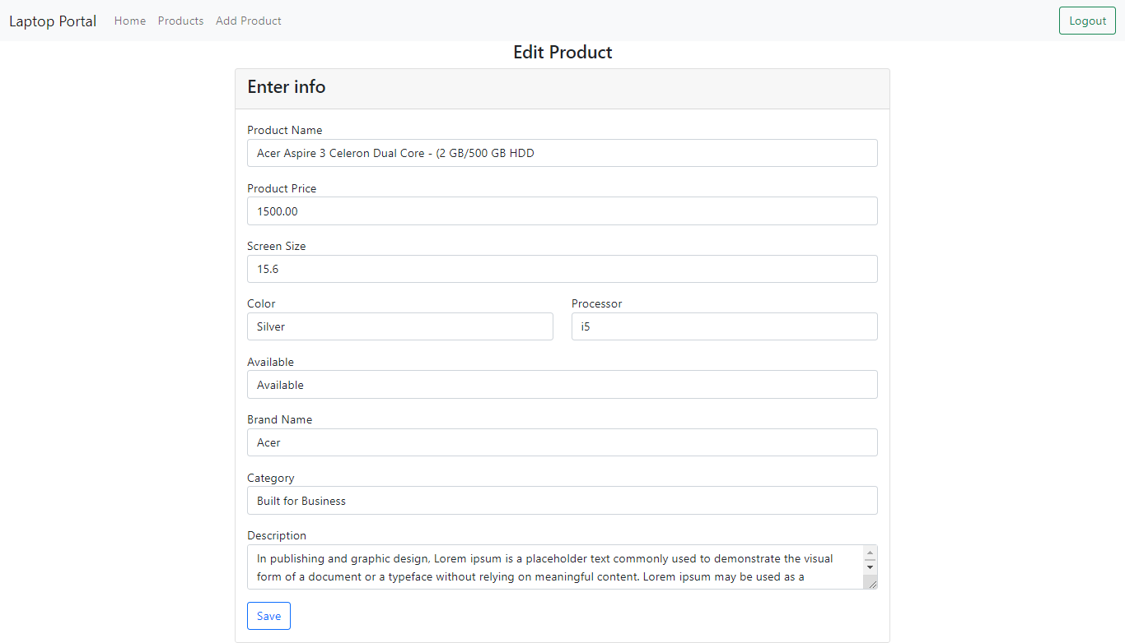

On this screen admin can edit the product information.

**Add product page:**

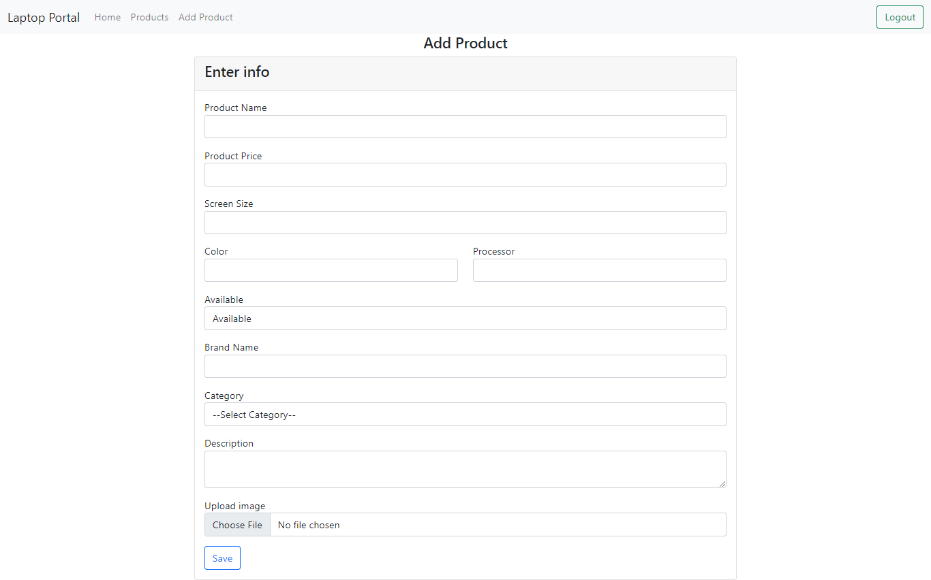

Admin can add new product in application from this page with a image